**Macros program guide**

This is a guide how to use a program. This program includes autoclicker and command macros.

1. **Chapter 1. Main menu**

Lets begin! Here is a main menu of program:

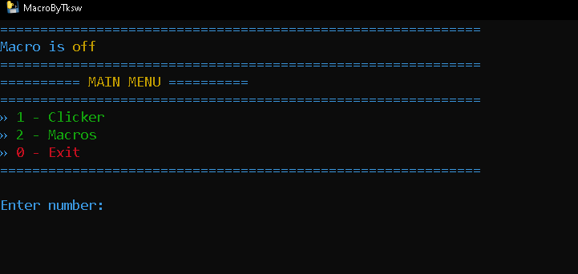

So it’s a main menu. Here you should input a number. In this case it`s 1,2 or 0 for exit. Also for better experience you can increase font of console text by holding “Ctrl” and scroll up or scroll up or down recpectively.

1. **Chapter 2. Autoclicker**

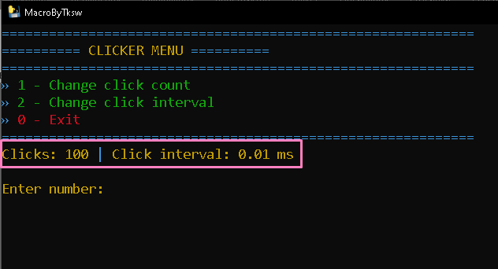

About clicker. During studying by bababoey course you used “OP Auto Clicker”

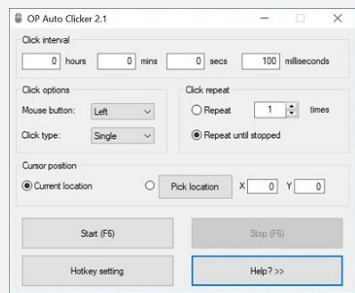

Here clicker work is a same. Main difference that here it has 100 clicks by default and click delay 10 milliseconds. Clicker start/end button is **F6**.

How to change clicker values?

1. In main menu enter 1. After it appears clicker settings menu.
2. In this menu enter 1 to change click count. After it put 123.
3. After it enter 2 and enter 20 here should be integer 1,2,3 etc.

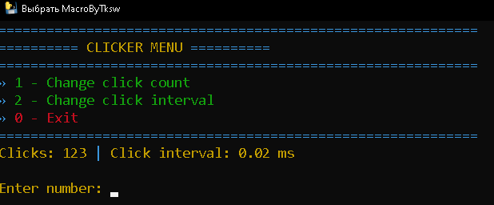

Done we just changed clicker settings

1. **Chapter 3. Macros module**

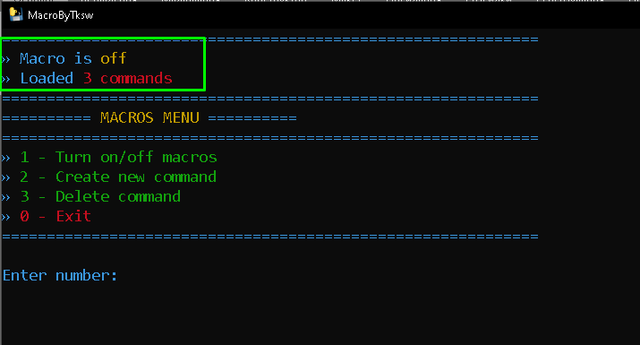

**In this menu we have 2 panels. First it`s info panel (Green square on screenshot) and second is menu panel.**

**Here is three menu options:**

* **Switch for turning on/off macros**
* **Create option**
* **Delete option**

So let`s talk about macros creation. In our case we have 2 type of commands. With dynamic data like “/forin 2 10 record dupe actor_1 actor_@{i}” and without it.

**IMPORTANT NOTE.** Here is 2 reserved word “MAXVALUE” and actorname_@{i} program reads your clipboard (CTRL + C) before input a command in chat and replaces *actorname_@{i}* on actorname from scene.

**So, to create command with dynamic data we should pass 3 steps.** It`s input a command with reserved data example:

/forin 2 MAXVAULE record origin actorname_@{i} 0 ~@{random()} ~ ~@{random()}

After it program asks us “Has Auto-replacing items (actorname)?” here 2 inputs its y(yes)/n(no). input a letter only!

And last step is key bind. Enter any key combination or any key. I will attach all keys in end, also key combinations should be divided by “+”. For now put “o+1”

Here is a result

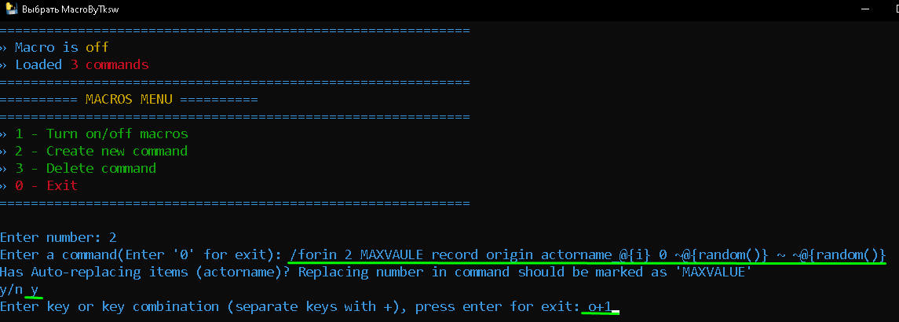

And after it counter in menu will be increased. It means that this macro is added and already in memory.

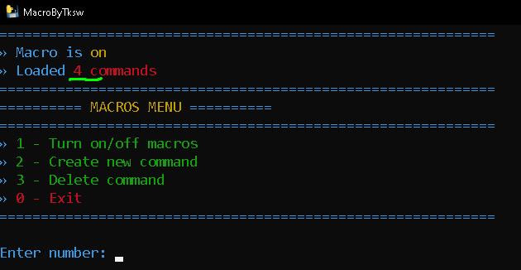

Delete function.

Here all is simple. Select 3rd menu option. After it type key or hotkey of macros what you want to delete and press enter

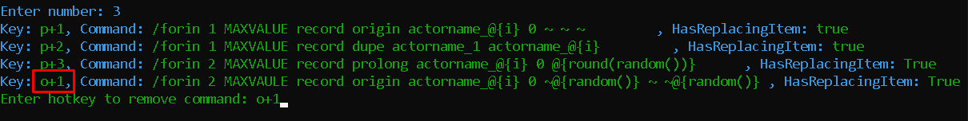

After it program delete macro from storage and refresh macroses in memory.

That’s all for now. If you have any questions contact “@Takisawa” or “@bababoey”.

KEYS AND KEY COMBINATIONS

**Main key names for binding:**

* a-z: letters
* 0-9: numbers
* enter, esc, backspace, tab, space
* shift, ctrl, alt
* caps lock, num lock, scroll lock
* up, down, left, right: Arrows

**Numpad key**s:

* num0-num9: numbers
* numlock
* divide (/)
* multiply (*)
* subtract (-)
* add (+)
* decimal (.)

Functional keys:

* f1-f12
* f13-f24 (some keyboards have this buttons)

**Other keys:**

* home, end
* page up, page down
* insert, delete
* print screen, pause